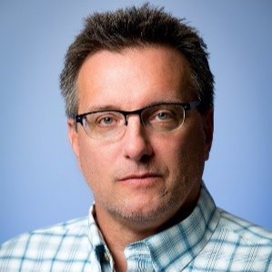Mr. Tracy Rolstad is presently employed as a Senior Power System Consultant at Avista Utilities (headquartered in Spokane, WA).

He has a BSEE from the University of Idaho and a graduate diploma from the Naval War College (College of Naval Command and Staff).
He started his career in power systems as a Reactor Operator and Engineering Watch Supervisor in the United States Navy (onboard USS Hawkbill) serving 22 years in the Navy and Navy Reserve.
His experience in power system planning and modeling began at the Joint Warfare Analysis Center and then developed and evolved at the Bonneville Power Administration (technical operations), as a Principal Engineer at Utility System Efficiencies, and now as a Consulting Engineer at Avista Utilities.
Tracy has served as the Western Electricity Coordinating Council (WECC) Technical Studies Subcommittee Chair, Vice-Chair, and Secretary. Additionally, he served as the WECC RAS and Relay Workgroup Chair addressing modeling issues related to 2011 AZ to CA outage. He is a member of the IEEE and the VFW.

